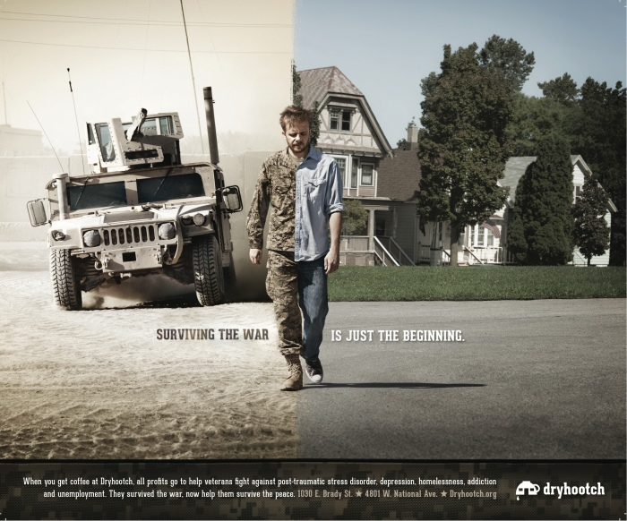

Training Agenda

8:00-8:50 – Jack O’Conner Peer Coordinator from Buffalo New York Veterans Court

8:50-9:50 – Why Peer Support is important

9:50-10:00 – Break

10:00-11:00 – Introduction and Role of a Peer Mentor

11:00-12:00 – Mentor defined, and our approach with Ethics and Boundaries

12:00-12:30 – Lunch

12:30-1:15 – Skills of a Peer Mentor

1:15-1:30 – Break

1:30-2:30 – Recovery Plan and Important Considerations

2:30-3:30 – Motivational Interviewing

3:30-4:00 – Questions and Recap

**1030 E. Brady Street, Milwaukee, WI 53202 Tel (414)455-8456** [**www.dryhootch.org**](http://www.dryhootch.org)

Milwaukee State Building

Basement

819 N 6th Street,

Milwaukee WI, 53202

March 23, 2015

8am –4pm

Materials

Pen and Notebook Needed

(Other materials will be provided including lunch)

Registration

Open registration starts on January 15, 2015

(No Fee)

Register at [www.WATCP.org](http://www.WATCP.org)

For any questions please contact:

Carol Carlson:

414-223-1341

[ccarlson@justicepoint.org](mailto:ccarlson@justicepoint.org)

Training

Information

Mission First People Always

Peer Support

Training